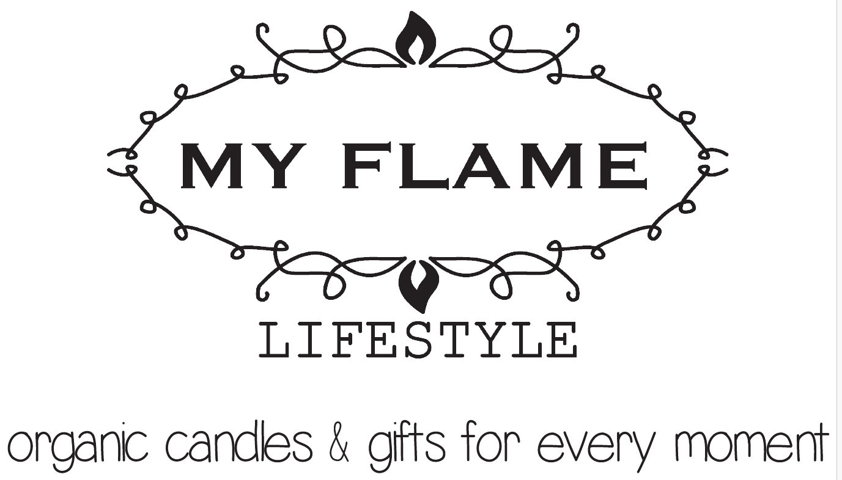

LINK PER LIBRERIA MEDIA:
https://www.dropbox.com/scl/fo/qfw9ow9ccm4eoutakv9yn/AM6_Uc-RfBlHT6KxB169R6I?rlkey=dkrjz09pd4b45wcvq3miy3xtl&e=1&dl=0

